Practical 5 and 6

Natya Vidhan Biswas
B.Sc. (H) C.S. 25771

5. Write a program to report behaviour of Linux kernel including kernel version, CPU type and CPU information.
#include <stdio.h>
#include <stdlib.h>

int main() {
printf("Kernel Version:\n");
system("uname -r");

printf("\nCPU Information:\n");
system("lscpu | grep 'Model name\\|Architecture\\|CPU(s)'"); // prints CPU details

return 0;
}

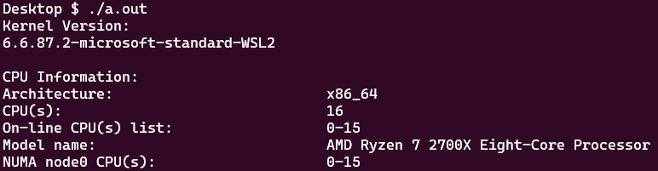

6. Write a program to report behaviour of Linux kernel including information on configured memory, amount of free and used memory. (Memory information)
#include <stdio.h>
#include <stdlib.h>

int main() {
printf("Memory Information:\n");
system("free -h");
return 0;
}

